[Requirements Specification]

s267620
Word Count: !!!!!

Contents
1. Introduction 2
1.1. Project Overview 2
1.2. Document Purpose 2
2. Scope 2
2.1. In-Scope 2
2.2. Out of Scope 3
3. Users 3
3.1. Intended users: 3
3.2. User Stories 4
3.3. Use Case 5

Introduction

Project Overview
This web-application is being developed for a web development company, the application will focus on both admin and client features. And will provide an interface for staff to see a list of all developers and assign them to websites as well as updating website details. There will also be space for clients to log in and be to book appointments with staff to commission a website or talk about and existing website. As well as an interface to allow clients to see up to date info on their website such as status and timeframe, as well as pay outstanding balances for their website.

Document Purpose
The purpose of the requirements specification document is to clarify the functional requirements and non-functional requirements for the application. This allows everyone involved in the development process of the application like the upper management and stakeholders to be able to see and understand the exact functionality of the application and be able to make changes if they are unsatisfied with the requirements. This ensures everyone is on the same page before the development of the application starts.

Scope

In-Scope
The Scope of the web development system requires these functional requirements:
- Admins to be able to log in
- Admins to be able to add, update and delete website and client information
- Admins to be able to add, update and delete developers on the developers list
- Admins to be able to assign and unassign developers from websites
- Clients to be able to log in
- Clients to be able to book, cancel and move appointments
- Clients to be able to see up to date info on their website
- Clients able to pay their balance.

Out of Scope
Features to be excluded due to constraints:
- User support
- Mobile support
- Accessibility
Due to time constraints of this project these non-functional requirements have been excluded to allow for timely deployment of an application that meets both the client’s needs and expectations. These features have been selected due to them having a minimal impact to the users and have a lesser degree of importance when compared to the functional requirements.

Constraints
Project limitations which will give guidelines to the developer, this will limit the features of the application but will also aid in timely completion of the application to required standards.
Constraint | Explanation
Time | Must be completed by the 08/03/2025.
Scope | The end product must complete all features listed in the scope section further features not required.
Legal Compliance | Law and legislation such as GDPR must be obeyed.

System Model

Intended users:
Users | Abilities
Admins | Ability to log in  Ability to control data stored on database. Add, update and delete. (websites, Developers and clients)  Ability to assign and unassign developers to projects.
Clients | Ability to create an account and log in.  Ability to book, cancel and delete appointments.  Ability to see website information.  Ability to pay current balance.

User Stories
An end goal, expressed from the software user’s perspective .

User stories | Acceptance Criteria
As an admin, I want to be able to log in so I can access my work. | Staff log in page can be selected from client log in page.  Admin account must be created by another admin to ensure security.
As an Admin, I want to be able to add, update and delete relevant data from the database so all information remains accurate and up to date. | Admin interface has pages such as client data, developer data and website data to allow for database change.
As an Admin, I want to be able assign and unassign developers from projects so they can be assigned where they’re most needed. | Admin interface has a developer page where developers can be assigned to websites via a website ID.
As a client, I want to be able to create an account and log in so I can book an appointment | Log in page will be first page to appear, able to go to create an account page by clicking create an account.
As a Client, I want to be able to book an appointment so I can talk about creating a website. | Client interface will have a book appointment page which will allow the client to select a date and time for the appointment.
As a client want to be able to see my website information, so I know what state my website is in. | Client interface will display current data about their website such as status and timeline.
As a client, I want to be able to pay my balance so I can use my website. | Client interface will have a pay page where client can pay their balance .

Use Case
Actors:
Client – create account, log in, Book appointment, view client interface, pay balance.
Admin – log in, modify data, Assign/unassign developers.
Use Cases:
- Create account – Clients can create an account .
- Log in – Clients can log in.
- View client interface – Clients can view Client interface.
- Book appointments – Clients can book appointments.
- Pay Balance – Client can complete payment.
- Staff login – Staff can log in separately from clients.
- Modify data – Admins can modify all data in regard to website, developers and clients.
- Assign/Unassign developers – Admins can assign/unassign developers from websites.
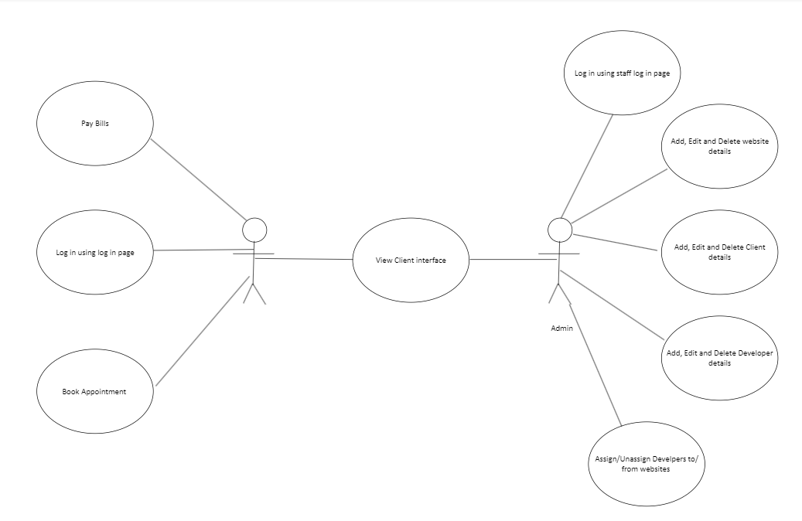
Use Case Diagram

Interfaces
The application interfaces will allow for a streamlined experience and easy usability for both the clients and the admins who will use the application. The table below describes all of the different interfaces that will be used and the details of each.

Interface | Description | Components
User interface (UI) | Will allow the client and admins to interact with the website. | Streamlined navigation  forms to allow data entry
Database interface | Will allow the database and website to communicate. | SQL execution  Data modification

References
Geeksforgeeks (2023) Architecture of a System. Available at: https://www.geeksforgeeks.org/architecture-of-a-system/ (Accessed: 03/03/2025)

